Yarmouk University

College of Information Technology
and
Computer Science
Department of Information Systems
Data Science & Artificial Intelligence program

DA499 Final project
Dr. Inas Khashashneh

Mohmmad Mahmmoud Sayal Al-Refa’e 2022905112

Dataset:
- Name: Fracture Multi-Region X-ray Data.
- It is an X-ray image of human bones.
- Objective: To differentiate between:
- Fractured bone.
- Unfractured bone.
- Image types within the dataset:
      - Upper limbs (arms)
      - Spine (lumbar spine)
      - Hips
      - Knees
Data structure:
- Training Set:
    - Number of images: 9246.
- Validation Set:
    - Number of images: 828.
- Test Set:
    - Number of images: 506
Concept:
This data is used to solve the following problem:
👉 Binary Classification Problem

Knowing the number of images in each file and their percentage of the total data:

Data distribution summary:
Region Label Count Percentage
0 test fractured 237 2.246871
1 test not fractured 267 2.531286
2 train fractured 4593 43.543800
3 train not fractured 4625 43.847175
4 val fractured 336 3.185438
5 val not fractured 490 4.645430

A diagram illustrating the data distribution mechanism:

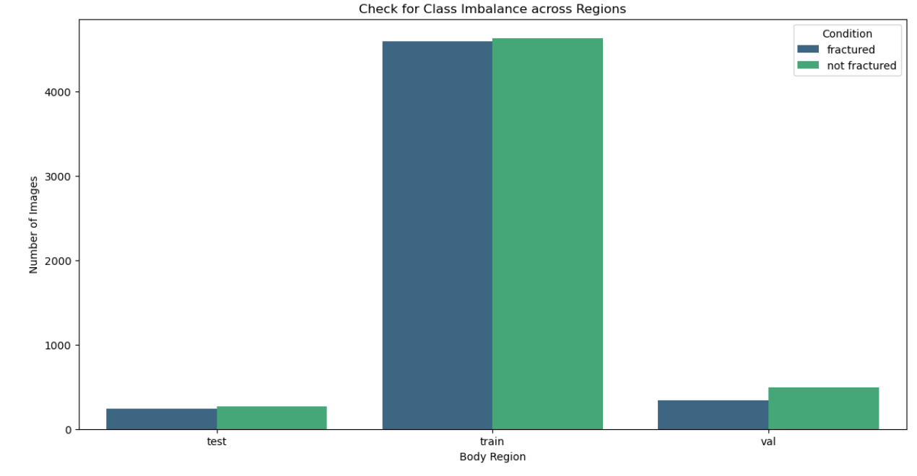

Identifying image extensions and how many of each extension are in each file:

  - Bone_Fracture_Binary_Classification\Bone_Fracture_Binary_Classification\test\fractured | .jpg: 237
  - Bone_Fracture_Binary_Classification\Bone_Fracture_Binary_Classification\test\not fractured | .jpg: 267
  - Bone_Fracture_Binary_Classification\Bone_Fracture_Binary_Classification\train\fractured | .jpg: 4593
  - Bone_Fracture_Binary_Classification\Bone_Fracture_Binary_Classification\train\not fractured | .jpg: 4625
  - Bone_Fracture_Binary_Classification\Bone_Fracture_Binary_Classification\val\fractured | .jpg: 336
  - Bone_Fracture_Binary_Classification\Bone_Fracture_Binary_Classification\val\not fractured | .jpg: 490

Identifying all pixels present in the image within each file:

Folder | Total Images | Min Pixels | Max Pixels | Avg Pixels
0 | Bone_Fracture_Binary_Classification\Bone_Fract... | 237 | 224x224 | 2328x2928 | 424x485
1 | Bone_Fracture_Binary_Classification\Bone_Fract... | 267 | 224x224 | 2460x2970 | 557x661
2 | Bone_Fracture_Binary_Classification\Bone_Fract... | 4593 | 100x100 | 4232x5823 | 289x312
3 | Bone_Fracture_Binary_Classification\Bone_Fract... | 4625 | 224x224 | 2460x3764 | 257x268
4 | Bone_Fracture_Binary_Classification\Bone_Fract... | 336 | 100x100 | 3000x4403 | 504x576
5 | Bone_Fracture_Binary_Classification\Bone_Fract... | 490 | 224x224 | 2460x2970 | 408x467

